**LEBANESE AMERICAN UNIVERSITY**

**USAID – HIGHER EDUCATION SCHOLARSHIP PROGRAM**

**HES - Volunteering Program Verification Form**

This form is to be used to document volunteering hours. If a student volunteers for multiple organizations, a separate form must be used for each organization. **This form must be turned in by the 28th of each month, the latest.**

I certify that the scholar Fatme Marwan Akar completed a total of 4 hours of service at Life Sculptor.

The hours were completed hours as per the below:

Hours # 0 (date) _02/09 - 06/09_ (initials of supervisor) __A.K.___

Hours # 0 (date) _09/09 – 13/09_ (initials of supervisor) __A.K.___

Hours # 0 date) _16/09 – 20/09 (initials of supervisor) __A.K.___

Hours # 4 date) _23/09 – 27/09 (initials of supervisor) __A.K.___

Brief description of the activities the scholar performed or participated in:

Fatme Akar is part of our PPT teams. She needs to prepare PPT on topics that the supervisor of the research team has assigned to her. She prepared PowerPoint presentations on the following topics: “Corporate Tax Compliance and Its Impact on Business & "The Imapct of Emerging Technologies on Financial Auditing" .

Written feedback about the scholar’s performance:

Fatme Akar, a dedicated member of the PPT team, was tasked with preparing presentations on topics assigned by the research team supervisor. She successfully completed PowerPoint presentations on “Corporate Tax Compliance and Its Impact on Business” and “The Impact of Emerging Technologies on Financial Auditing,” showcasing her ability to clearly present complex subjects with attention to detail and precision.

Please rate the overall performance of the scholar at your organization:

|  |  |  |  |
| --- | --- | --- | --- |
|  | Mastery (5) | Proficient (3) | Emerging (1) |
| **Problem solver** | X |  |  |
| **Engaged & Committed** | X |  |  |
| **Open-minded & multicultural** | X |  |  |

Signature

& stamp

__________________________

_

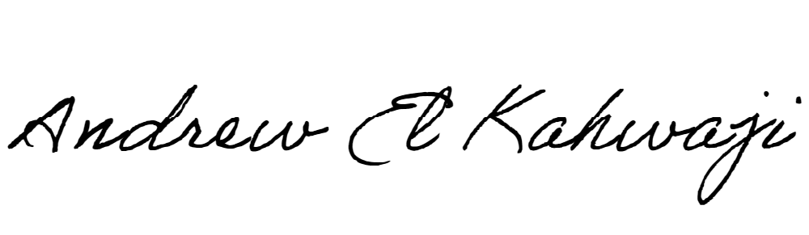

Printed Name _Andrew El Kahwaji_

Date __25/09/2024___

Email __andrew.lifesculptor.coo@gmail.com __

Phone __+961 71 914 378__

**LEBANESE AMERICAN UNIVERSITY**

**USAID – HIGHER EDUCATION SCHOLARSHIP PROGRAM**

